APPLiA Europe Trilogue Position on CBAM Scope Extension to Downstream Goods
Ahead of the upcoming CBAM trilogue negotiations, APPLiA Europe calls upon co-legislators to incorporate a broader range of home appliance products into the final text. While APPLiA welcomes the inclusion of additional appliance codes in Annex I under both the European Parliament's position and the Council's General Approach, the Council's text omits several key codes originally endorsed by Parliament.
To this end, APPLiA urges co-legislators to include the home appliance CN codes supported in the EP Plenary amendments but omitted from the Council's General Approach and the Commission's proposal. For comparison, please refer to the comparative table attached below detailing the CN codes proposed by the European Parliament and the Council.
CBAM-covered materials like steel and aluminum account for 57% of the European home appliance sector’s annual material consumption. As free ETS allowances phase out, excluding remaining large household appliances from the CBAM scope exposes the sector to severe competitive disadvantages. Extending CBAM to these products is necessary to establish a level playing field between EU and non-EU manufacturers, achieve cross-policy coherence, and maintain Europe's economic resilience.
Leaving certain appliance categories out of scope creates carbon leakage and circumvention risks in two key areas:
- Same-use products: Excluding variants of covered goods creates a glaring loophole, offering importers an easy way to bypass the carbon price.
- Adjacent products: Excluding items with similar material compositions and shared production chains sends contradictory carbon price signals to investors, who make strategic decisions at the factory level rather than the product level.
Specifically, we believe the following CN codes already endorsed by the European Parliament shall be included in the final text, as they serve practically the same function as others already in scope (so-called “same use products”):
- Washing machines and drying machines > 10 kg (missing in the Council’s text, while those < 10 kg are already proposed for inclusion by the Commission and endorsed by the Council) – 845020, 845129
- Electric water heaters (missing in the Council’s text, while non-electric water heaters are in scope) – 851610
- Equally, the following CN codes already endorsed by the European Parliament shall be included in the final text as well, as they are materially and economically very close to those already in scope and part of the same industry sub-sectors (so-called “adjacent products”):
- Dishwashers (very similar to washing machines in material composition and often made by the same producers, which are already in scope) – 842211
- Ovens, hoods, cookers (CBAM material composition around 60-80%, typically made by the same manufacturers as other home appliances already in scope) – 85166080, 85166010, 841460
- Radiators, heaters (functionally close to covered goods like water heaters and boilers) – 85162910, 85162950
On the other hand, there is one code covered by the APPLiA scope that we request not be included in the final list of scope extensions for finished products: electric grillers and roasters under CN code 8516 60 70. This specific category lacks an established EU manufacturing footprint that would necessitate carbon leakage protection. Extending CBAM to a product code without domestic production would only create administrative and financial burdens for European companies without delivering any protective or environmental benefit for EU manufacturing. Differentiating this code based on the absence of EU production ensures the consistency and validity of our broader criteria for scope extension. As such, we request that co-legislators exclude CN code 8516 60 70 from the final list, maintaining alignment with the principles previously shared with members of the European Parliament.
We also recommend the co-legislators to strive for a granular and predictable CBAM scope, by using at least 6-digit, ideally 8-digit CN codes, targeting specific product groups instead of broad categories, and prioritising finished goods before components (often more valuable, often more exposed to carbon leakage).

Moreover, when unfeasible demonstrating the risk for all goods falling under a specific CN code, we propose to add the “ex” (exemption) in front of the code to indicate a restrained application, in line with general customs practice.
Extending the CBAM scope to home appliances is critical across four key areas:
- Fair carbon pricing preserves the case for EU-based manufacturing, protecting European jobs, growth, and industrial investments from declining under the ETS.
- It reinforces European competitiveness as carbon prices rise over the next 5–10 years, preventing EU manufacturers from facing increased exposure to unfair foreign competition.
- Establishing a complete policy framework improves economic security by removing the incentive for finished goods manufacturers to relocate outside Europe.
- This extension enables decarbonization, ensuring carbon pricing achieves its climate goals by preventing production and emissions from simply shifting abroad.
Finally, while APPLiA welcomes the proposed Temporary Decarbonisation Fund (TDF) to mitigate export carbon leakage risks for heavy raw materials, we stress that producers of finished goods—such as home appliances—face identical export risks once included in the CBAM from 2028. Unlike upstream ETS sectors that benefit from targeted trade protections (e.g., steel safeguards) and TDF support, home appliance manufacturers remain exposed to structural trade asymmetries and foreign indirect support.
To prevent EU exports from losing their competitive edge globally, finished goods producers must be eligible for TDF support (or its post-2028 successor). Furthermore, to safeguard fair competition, robust anti-circumvention measures must ensure that actual emissions data submissions are strictly verifiable without creating unnecessary administrative complexity.
ANNEX
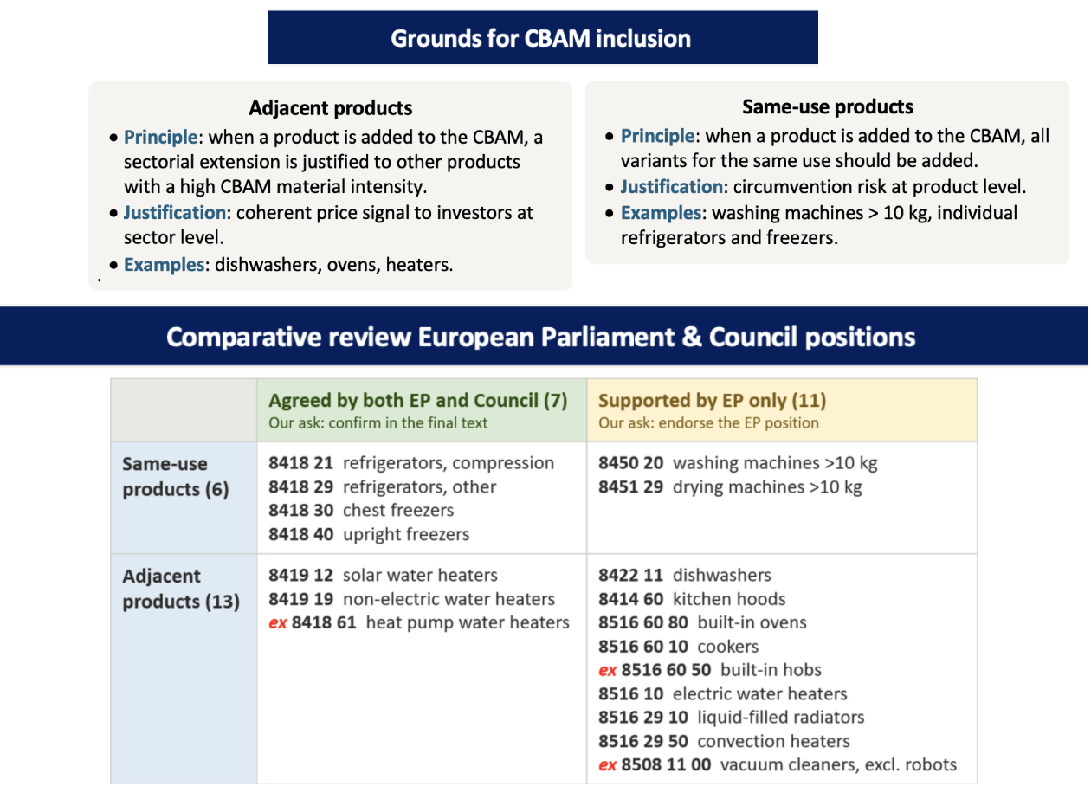
The comparative table below focuses on the CN codes proposed for inclusion by the European Parliament, by the Council of the EU, or both. Additionally the explanatory notes detail our argumentation on adjacent and same use products. For all of those CN codes, APPLiA can provide supportive evidence showing a risk of carbon leakage and/or circumvention due to CBAM material composition, tradability, and carbon costs.

